**TRUBA QnA**

**MAJOR PROJECT REPORT**

**Submitted in partial fulfillment of the requirement for the Degree of Bachelors of Engineering in Computer Science & Engineering**

**Submitted To: Prof. Amit Saxena (HOD,CS Dept.)**

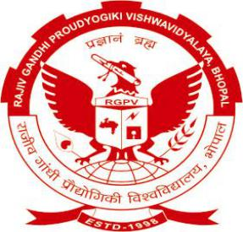

**[RAJIV GANDHI PRODYOGIKI VISHWAVIDYALAYA, BHOPAL (M.P.)]**

**Submitted By: Abhishek Argarey (0114CS161004)**

**Group Members:**

**Abhishek Argarey (0114CS161004)**

**And Amber Pandey (0114CS161020)**

**Under The Guidance of:**

**Miss Neha Gupta**

**(Teacher , Computer Science Department)**



**DEPARTMENT OF COMPUTER SCIENCE & ENGINEERING / INFORMATION TECHNOLOGY**

**TRUBA Institute of Engineering & Information Technology, Bhopal**

**SESSION: 2019 - 2020**

**TRUBA INSTITUTE OF ENGINEERING & INFORMATION TECHNOLOGY, BHOPAL**



**(Session: 2019 - 2020)**

**DEPARTMENT OF Computer Science And Engineering**

**CERTIFICATE**

This is to certify that **Abhishek Argarey** and **Amber Pandey** Students of **CSE - VIII Semester** of **“Truba Institute of Engineering & Information Technology, Bhopal”** has completed their Major Project titled **“PROJECT NAME”**, as per the syllabus and has submitted a satisfactory report on this project as a partial fulfillment towards the award of degree of **Bachelor of Engineering** in **Computer Science and Engineering / Information Technology** under **Rajiv Gandhi Proudyogiki Vishwavidyalaya, Bhopal**.

**NEHA GUPTA Prof. AMIT SAXENA Dr. RAJEEVARYA**

**(Project Guide) Head(CSE / IT) Director**

**(Teacher) TIEIT, Bhopal TIEIT, Bhopal**

**(CSE / IT)**